Paper title
Author Name¹, Author Name²
¹Name of institution, address
²Name of institution, address
e-mail of corresponding author
Abstract: Abstract — brief and informative, not to exceed 250 words. No abbreviations should be used in the abstract. Key words — a maximum of 6, in alphabetical order, suitable for indexing. Abbreviations — arranged alphabetically, only those which are not familiar and/or commonly used.
Keywords: a maximum of 6, in alphabetical order, suitable for indexing
Introduction (Title of first order)
Original papers describing original research should not exceed twenty pages of printed text, including tables, figures and references (about 40 000 characters including space occupied by Tables, Figures and Schemes). These will usually be published within six months after acceptance.
Review papers not exceeding 20 pages of printed text, including tables, figures, and references. However, in scheduling manuscripts for publication, preference will be given to original research reports. Reviews should be authoritative, critical and comprehensive evaluation of research conducted in previous years in the areas of topical interest. Prospective authors of reviews should first send an outline of the proposed article to the Editor-in-Chief with a brief letter explaining why the subject might be of wide interest or significance. Papers already published or in press elsewhere will not be accepted. Papers of restricted local importance will not be accepted. Manuscripts should be written in English and should be submitted in electronic form.

Fig. 1. Structure of…
Main text. Recommended font type is Times New Roman (Arial or Helvetica) for main text, figures and schemes, font Symbol for symbols. The text should, if possible, be developed under the following headings:
Introduction, Materials and Methods, Results and Discussion. New paragraphs should be indented. The use of footnotes should be avoided. However, if essential, they should be typed on the appropriate page, but clearly separated from the text with a line above them. Acknowledgements (also grants support, etc., if any) should follow the main text and precede the references. Notes should be numbered consecutively in the text with superscript numerals and listed in numerical order after the Acknowledgements.
All equations, including those describing chemical reactions should be labeled with numerals. Also all mathematical equations should be numbered. In equations, symbols of variables must be written in italics. The sub- or super- scripts should be written in normal style unless they represent a physical quantity such as pressure in the symbol of CP. The meaning of the symbols should be explained immediately below the equation. The equations inside of paragraphs are preferred to type as a text (not as an equation) if possible.
All terminology used should comply with the recommendations of the IUPAC.
Tables and figures should be numbered, starting from 1. They should be embedded within the document, approximately in the place, where they should appear in the publication. Figures should be pasted into the Word document so that they could be edited using the software in which they were created. Schemes and charts with complex reactions and compounds, respectively, are considered figures and numbered consecutively in order of appearance in the text. Chemicals are denoted by roman numerals according to their order of appearance in the text. Figures must be supplied in the true reproduction size, as legible black-and-white vector graphics or bitmaps with the minimum resolution of 600 ppi (dpi) for back-and-white bitmaps and 300 ppi (dpi) for grayscale or color bitmaps. Color bitmaps are accepted for the electronic version of the journal but the authors are charged for the color print. At sending the final, revised manuscript, each bitmap figure should also be sent as a separate file in a bitmap or vector format (TIFF, EPS, JPEG with minimum compression, exceptionally BMP, GIF) with high resolution to preserve image quality (not resampled images).
Figure below illustrates the recommended form of graph and its caption. The symbols of variables must have the same form and style as in the main text. It is recommended to label curves by a short intelligible symbol, especially, if the plot contains several curves. The symbols used must be explained in the figure caption. The recommended fonts are Times New Roman (Arial or Helvetica). Some deviations from this form are allowed, if a unified form of figures is used within the manuscript. Recommended width size is 80 mm (maximum 165 mm) with respect to font size 10 pts.
Material and Methods
Chemicals (Title of second order)
If several plots are included into one figure, they should be distinguished by letters in the left-hand (right-hand, in case of the lack of space) top corner of the plots (Figs. 2a and 2b). It is recommended to use the symbols of variables not their names in the axis titles. The axes values should not have more than three digits. In order to avoid that, the axis quantity should be multiplied by an appropriate factor. If numerous symbols are used repeatedly throughout the main text, these should be listed in a separate chapter. All symbols, names, and units of variables used throughout the manuscript must be included in alphabetic order.

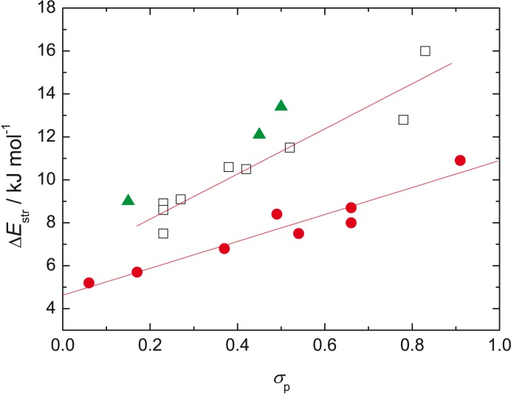

a) b)
Fig. 2. Dependence of…
Each figure should be mentioned in the text.
Line drawings must be in black on white background, and should not contain shading (1 pts line are recommended). Extremely small font size should be avoided, figures are often reduced in size. Font size 10 pts is recommended with respect of picture width from 80 to 165 mm (24 or 36 pts in some graphic programmes). Symbols should have the magnitude of 8—10 pts. Halftone reproductions must be clear, well-contrasted and cropped at right size. Figures as well as legends should be identified by Arabic numbers and headed “Fig. 1”, etc.
Where multi-part figures are used, each part should be clearly identified in the legend, preferably with (lower case) letters. Do not give magnification or scales in the figure legends: instead draw bar scales directly on the figures.
Literature references should be listed alphabetically, typed double-spaced, and in the text referred to by author name and year of publication enclosed in parentheses, e.g. (Fišera, 1989; Blacksmith and Hargreaves, 1999; Devera et al., 2009). Citations of personal communications and unpublished data should in text appear only as: (J. Biely, personal communication), (J. Švitel, unpublished), and not in the reference list.
References should contain: author(s) name(s) followed by author(s) initials, year, journal, volume number, and inclusive page numbers. Books must include the location and name of the publisher.
Δ_{r}H(A_{AC}2) = H(R—NH₃⁺) + H(HCOOH) –
– H(R—NHCO) – H(H₃O⁺) $PA=H\left({XN}^{-}\right)+H\left(H^{+}\right)-H(XNH)$(1)
k_{H} = –22.6(3.1) + 0.298(49) Δ_{r}H(A_{AC}2) (2)
Tab. 1. Tables should be numbered with Arabic numerals, followed by the title. Both horizontal and vertical rules should be indicated. Table footnotes should be marked with superscript numbers. Each table must be mentioned in the text, approximately in the place, where they should appear in the publication. Use only simple thin lines in the table.
Substituent | Hammett  constants |  |  | k_{H}/hr^{–1} |  |  | Δ_{r}H(A_{AC}2) |  |  | Δ_{r}H(B_{AC}2)
 | σ_{p} | σ_{m} |  | para | meta | ortho | para | meta | ortho | para | meta | ortho
—NO₂ | 0.78 |  | 0.71 | 27.30 | 11.30 | 24.9 | –42.394 | –48.503 | –71.078 | –103.114 | –89.267 | –138.180
—COOH | 0.45 |  | 0.37 | 18.20 | 8.21 | 24.6 | –50.108 | –54.988 | –95.621 | –93.129 | –84.875 | –133.698
—Br | 0.23 |  | 0.39 | 8.32 | 10.80 | 2.57 | –55.566 | –53.615 | –70.833 | –83.449 | –85.838 | –115.798
—Cl | 0.23 |  | 0.37 | 7.04 | 9.65 | 7.24 | –56.152 | –53.715 | –76.512 | –83.192 | –85.691 | –115.136
—H | 0.00 |  | 0.00 | 7.39 | 7.39 | 7.39 | –60.302 | –60.302 | –60.302 | –81.159 | –81.159 | –81.159
—Ph | –0.01 |  | 0.06 | 7.53 | – | 3.17 | –59.334 | –59.814 | –92.546 | –81.889 | –81.551 | –114.388
—C₂H₅ | –0.15 |  | –0.07 | 4.60 | 6.21 | 2.07 | –62.366 | –61.576 | –99.220 | –78.411 | –80.632 | –116.357
—isoC₃H₇ | –0.15 |  | –0.05 | 5.42 | 6.05 | 1.39 | –62.264 | –62.151 | –102.234 | –78.555 | –80.233 | –118.841
—CH₃ | –0.17 |  | –0.07 | 5.06 | 6.58 | 2.57 | –62.080 | –61.198 | –97.910 | –77.859 | –80.335 | –115.874
—OCH₃ | –0.27 |  | 0.12 | 2.95 | 8.59 | 5.23 | –63.857 | –59.418 | –91.302 | –75.919 | –82.483 | –111.006
—OH | –0.37 |  | 0.12 | 2.67 | 7.80 | 3.81 | –63.285 | –56.293 | –105.984 | –75.420 | –83.126 | –125.614
Chromatographic conditions…
Acknowledgement (Title of third order)
Each equation should be mentioned in the text, copied from equation editor.
Equation as a part of paragraph should by written only in simple form — ρ = m/V without using equation editor, otherwise must be in separated numbered line as standard equation. If very special symbols are used in equation then must be exported from equation editor as a bitmap picture (TIFF or JPEG, 600 dpi) in original size. Font Times New Romand and Symbol is recommended.
Abbreviations and units. SI units should be used, e.g.: mg, g, kg, km, m, cm, mm, ppm, cpm, qmCi (microCurie), L (litre), mL, s (second), min (minute), h (hour), mol, m³, kg per ha or kg ha^{–3}. If a non-standard abbreviation is to be used extensively, it should be defined in full and follow the abstract.
References
Arai T, Matsuda H, Ōizumi H (1989) J. Chromatogr. 474: 405—410.
Deáková Z, Ďuračková Z, Lehotay (2014) J. Chem. Listy 108: 436—441.
Płonka J, Toczek A, Tomczyk V (2012) Food Anal. Methods 5(5): 1167—1176.
Zappala AF, Simpson CA (1961) J. Pharm. Sci. 50(10): 845—847.

